COLLECTED POEMS OF JOHN MEADE FALKNER
Published on 8th May, 2005 by the John Meade Falkner Society.

Meade Falkner wrote poetry throughout his life, having several published in The Spectator and the Cornhill magazines. Early in the summer of 1932, the first steps were taken to collect them together and publish them in booklet form. Anne Falkner was staying at the family home in Weymouth and found a bundle of her brother's verse which she had typed up previously. When she showed them to Meade Falkner, he produced some more. By the time he returned home to Durham, a very ill man, a selection had been sent off to Geoffrey Madan, who promised to take charge of their publication. Falkner remarked, "I should like to live to see them through". Within eight weeks he was dead.
Two editions were published - the earlier, brown-wrappered one contained several misprints, and a green-wrappered version, with corrections, was ordered by his widow, Evelyn, in an edition of 500 copies. The first version is rare but copies of the second appear occasionally.
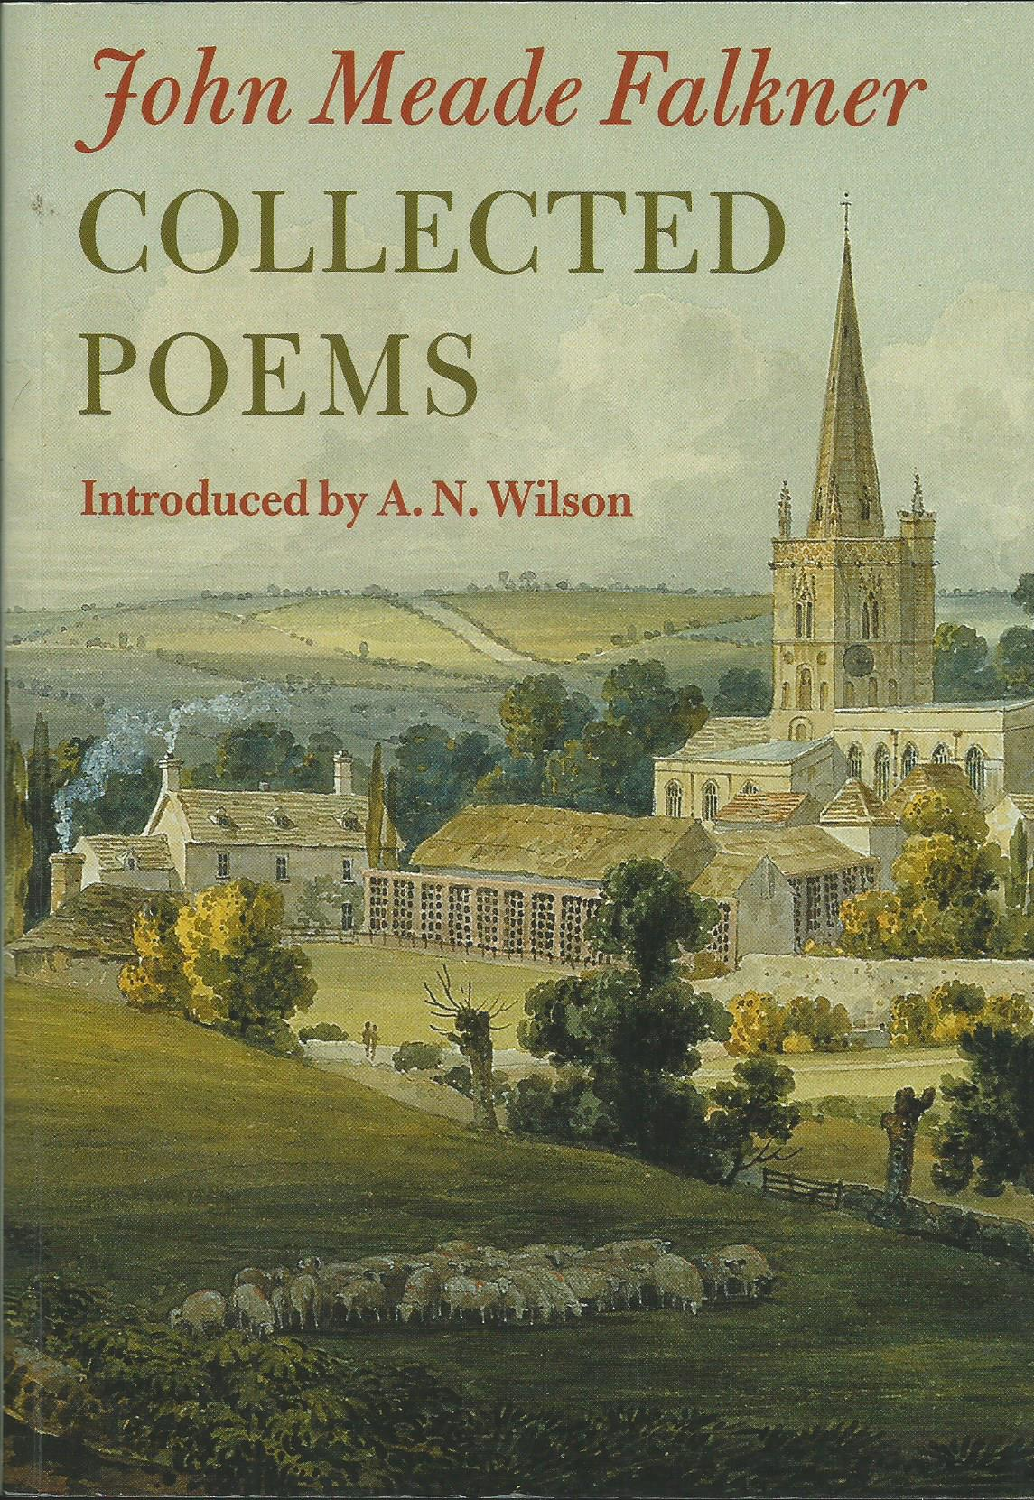
This edition includes six extra poems not in the previous publications. There are also Notes to most of the poems. A. N. Wilson, in his Introduction, concludes that "it is good to have his collected verses in one volume. They are a testimony to a lifetime's love of the past, a patient sensitivity to its old echoes, and a wistful humility in the presence of its wisdoms".
The Collected Poems has been published in a limited edition of 300 copies, on 115 gsm cream antique laid paper with a gloss colour cover. The binding will be in sewn sections and glued. The ISBN is 0-9547799-0-8.

The cost is £11 + £4 p & p in the U.K. [overseas orders are £20 including postage].
I/We would like to purchase ____ copy/copies of the Collected Poems and enclose a cheque for £ ______
[to be made out to "The John Meade Falkner Society"
NAME[S] .................................................................................................
ADDRESS ...............................................................................................
....................................................................................................................
....................................................................................................................
[BLOCK CAPITALS, PLEASE]
Send, with remittance, to: Kenneth Hillier, Greenmantle, Main Street, Kings Newton, Melbourne Derbyshire DE73 8BX

